W01 Assignment: Team Organization
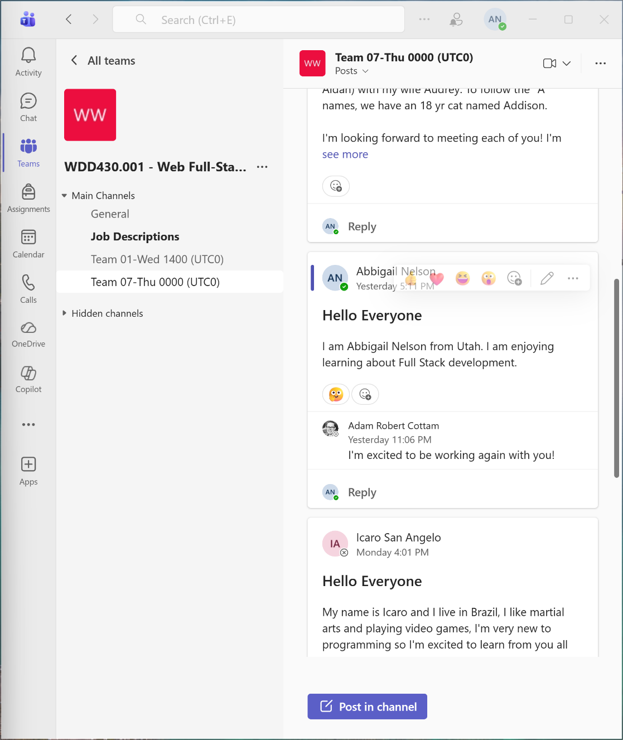
Group Name: Team 07
Meeting Time: UTC Thu 0000
Group Leader Week 02: William Jezek

